Method 1：
1.Copy the mdmcpq.inf file to C:\Windows\inf;
2.Copy the usbser.sys file to C:\Windows\System32\drivers;
3.Replug the USB line, restart the computer, observe the driver installation situation.
Many people can solve the problem with the two steps above.

Method 2：
If the installation is still failed:
1、To the Aarduino installation directory (for example: my own installation directory for the D:\Arduino\soft), find the drivers folder, open the can find a compressed file: Old_Arduino_Drivers.zip, the compressed file decompression to Old_Arduino_Drivers folder on the D: \Arduino\soft\drivers (cross section for your installation directory, change according to their own installation directory no tips).

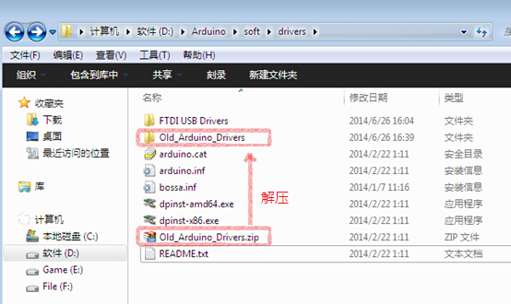

2、Insert the USB line again. Then, right click on my computer, open the device manager to see the installation of Arduino drive device. At this point, the Arduino driver device should be displayed as "unknown device", right click on the "unknown device" and choose "update driver software".
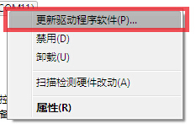

3、Select "browse the computer to find the driver software".
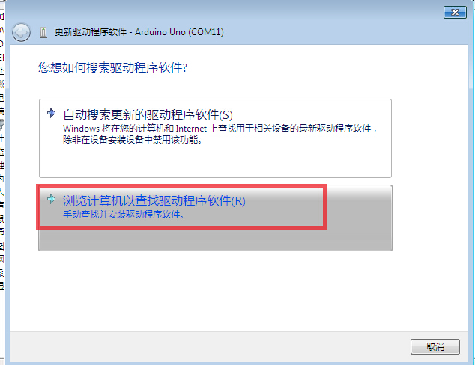

4、Write the folder that just unpacked into the following box and click on the next step.
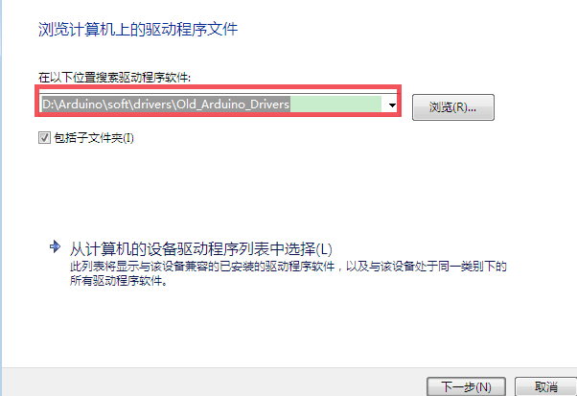
5、The waiting driver is installed successfully.
Method 3：
If the installation fails：
1、open the C:\Windows\inf\setupapi.dev.log log file , and the PC hardware installation is recorded in it. Because the Arduino driver is just installed, go to the end of the log file to find the installation information.
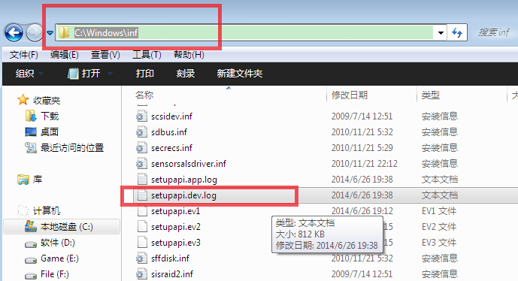

2、Look for a similar directory address in this log file.
In general, the first half of the directory address
（C:\Windows\System32\DriverStore\FileRepository）is same，the second half is different,For example, my folder name is arduino.inf_x86_neutral_844213a156728dfe。
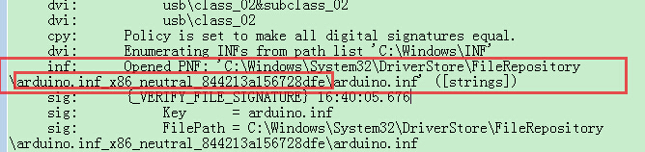

3、Go to C:\Windows\System32\DriverStore\FileRepository and find your own Arduino folder.
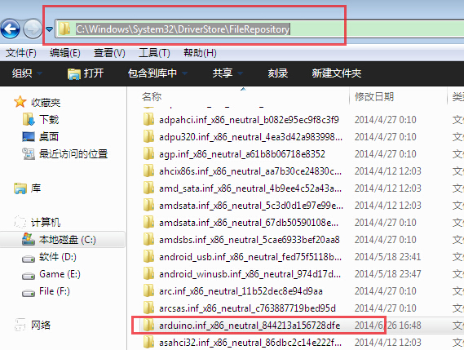

4、Open this folder and copy the 4 files of Arduino UNO REV3.inf, mdmcpq.inf, mdmcpq.PNF, usbser.sys to this folder. (as below)

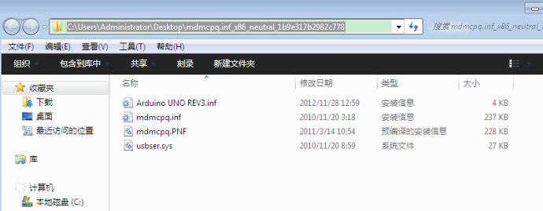

5、Replug the USB line and wait for the driver to install successfully.
